[Insert document name]

Subtitle (if needed)

Contents

Heading 1 3

Heading 2 3

# Heading 1

## Heading 2

### Heading 3

Body

*Table 1 – Definitions*

|  |  |
| --- | --- |
| **Term** | **Definition** |
|  |  |
|  |  |

1. Interactive User interface prototype

The functional requirements for the application are:

* Access to staff directory
* Access to staff contact information
* Compatible with all versions of ANDROID

Below are screen grabs of the UI Prototype featuring Landscape and Portrait Resolution and they are scalable to any android Size.

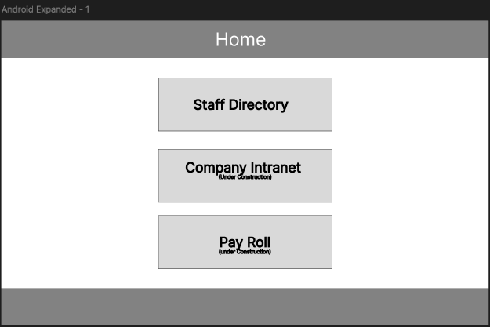

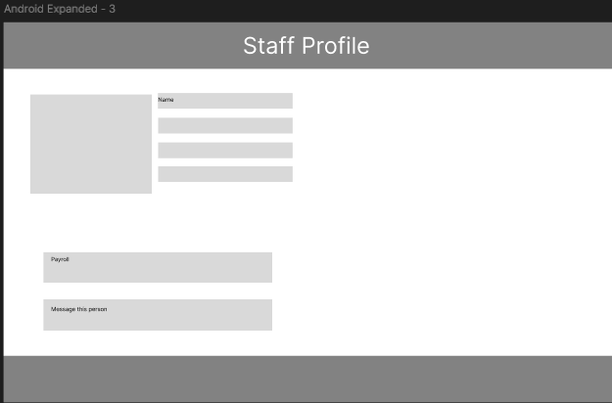

Link to Prototype UI

https://www.figma.com/proto/82RpDpfJtHOAtfFig8uf0g/ROI-APPLICATION-2nd-Version?node-id=0-1&t=2ouugtAmmCYKHzki-1